

**Solution Architecture:**

Implement a centralized database or data warehouse that serves as the primary repository for data. This centralization ensures data consistency and accessibility. Employ robust user authentication and authorization mechanisms to control access to the system. Implement role-based access control, allowing administrators, educators, students, and parents to access specific data and functionalities based on their roles. Develop data integration processes and ETL workflows to consolidate data from various sources. These processes should include data mapping, transformation, and validation to ensure data accuracy before it is stored in the central repository. Build a data analytics and reporting engine that allows users to create, customize, and schedule reports and visualizations. Implement data analytics tools to derive meaningful insights from the educational data, aiding data-driven decision-making.

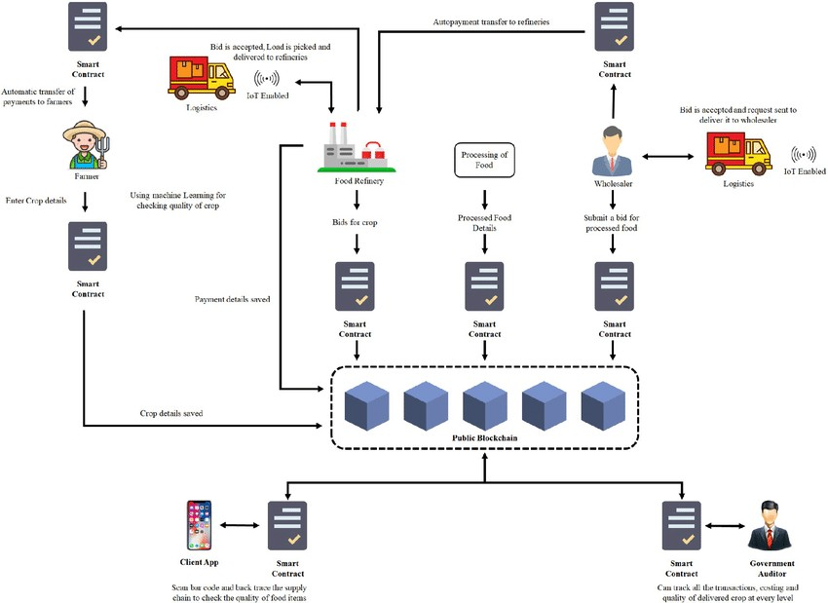**Solution architecture:**

**DATA FLOW DIAGRAM:**

